The gentle and strong way of Tai Chi
By HENNESSY JEAN RANGAS
11/03/2010 | 11:56 AM

It was 6 a.m. on a Sunday but instead of sleeping in, I was up early and walking briskly to attend my morning session of Tai Chi. Though I was only accompanying a friend, I wanted to observe and see for myself if the moves are really as elegant as the ones depicted in images and videos I saw online.
I had always wanted to practice a martial art both for fitness and for self-defense but I was too scared to break any bones. The fact that Tai Chi (literally translated "Supreme Ultimate Boxing") was actually a fighting style that employed gentle movements got me even more interested. It made me think about old kung fu movies and the cool moves of Bruce Lee, Jackie Chan and Jet Li.
The instructor that morning was Antonio "Ton" Delgado. His unassuming nickname and pleasant demeanor hides the fact that he is a Tai Chi and Qi Gong Instructor from the Peace Blossoms Internal Arts Society. According to their website, the society “is a non-profit, non-sectarian, and non-political recreational club with the mission of promoting and integrating peace and harmony in the myriad activities of daily life since a life lived in radiant peace blesses one with the natural treasures of health, wealth, success, and prosperity."
Ton and other instructors from the society take turns giving free Tai Chi lessons at different venues. They are also invited by different organizations to give seminars and lectures on Tai Chi and whatever fees they receive from these activities are contributed to their organization.
Different Strokes for Different Folks
As we arrived at the venue, we saw four women, maybe in their 60s, and another male instructor about their age, swaying their bodies in a rather funny-looking dance. I wanted to join in as they looked like they were having fun. Ton informed me that this was a Qi Gong move called the Swimming Dragon and was a particular specialty of his fellow instructor.
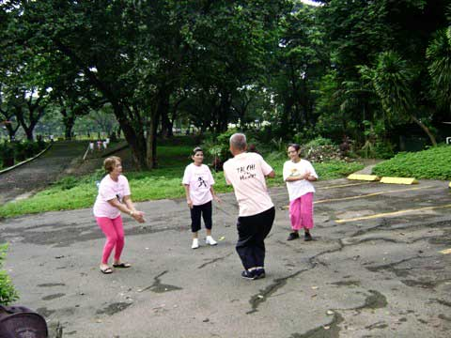
A group practicing the Swimming Dragon, a move that helps promote metabolism.
Ton said that it takes a lot of time to actually master a particular style and instructors choose one that suits them best. He chose to master Shibashi that combines traditional breathing and movement exercises.
Instructors also have different teaching styles. In his own classes, Ton prefers to integrate meditation and visualization techniques. He finds that most students in his classes actually look forward to doing them.
Meditation and Visualization
Ton instructs the class to visualize the different energies surrounding them. In a process called rooting, he asks permission from Mother Earth to let the energy, or chi, flow from the earth into his own body. Then, he tells the class to stretch their body, holding their head up like it was hanging from a thread. In this stance, they welcome the energy from heaven, from the wind and from the sun. The class then visualizes this chi to flow into their body through their pores as they breathe in.
This same chi is used to gather all the negative energies already present in the body, may it be due to sickness or external stress. When all the negative energy is gathered, they visualize it transforming from dark to light, light being the color of positive chi; this begins the process of healing the body. However, the visualization does not stop here.
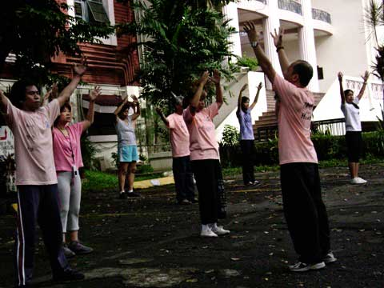
A welcome stance to gather chi from Mother Earth.
The class is then asked to release this positive chi from their bodies and radiate peace, love and harmony into the surrounding environment, then to the whole community, the whole nation, the whole planet and yes, even into the whole universe.
Together with slow and soothing music, this visualization process made me feel very relaxed and peaceful, even if I was just watching the class and observing. The concept of transforming negative energy into positive energy using one’s own body and spreading this positive energy to the whole universe seemed to be a very powerful experience. Instead of rechanneling bad energy into other things, your own body becomes a transformation agent and with this kind of power, it is not hard to believe that healing one’s own body is indeed possible.
Relaxed and alert, members of the class were ready to participate in the next Tai Chi exercises which consisted of exercises for diabetes, for arthritis and for back pain.
All the movements were done in slow and fluid motions; the positions flowed into the other like an elegant dance in tune with the music. There were so many movements with different names that it was hard to memorize them. But I noticed there were common movements in all the exercises and some were memorable as they remind one of some stances in martial arts films.
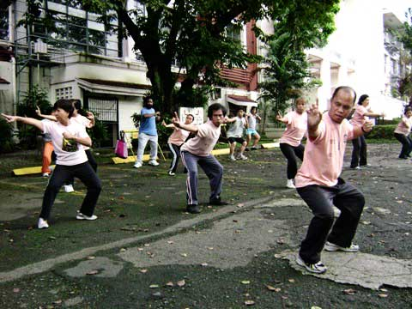
"Drawing the bow"
My friend told me that even if it was her first time to attend the class, she didn’t feel embarrassed or pressured since the movements focused more on the correct posture than on speed. Once you've mastered the postures, the transitions between them would become easier to follow.
The Healing Power of Tai Chi
From the visualization to the next set of exercises, it was apparent that Tai Chi is not just practiced for fitness but also for healing.
Ton himself has proven the healing power of Tai Chi. He said he used to practice Jeet Kune Do, the martial art popularized by Bruce Lee. But after injuring his knee, he searched for a way to heal himself and came upon Tai Chi. With continued practice, the gentle martial art not only helped him heal his knee injury but also a lung tumor. It was then that he decided to practice Tai Chi full time.
Having experienced Tai Chi's healing powers, Ton also assisted his father’s bed - ridden friend to heal himself. He helped him perform the daily exercises by lifting his arms and legs for him. After a few weeks, his father's friend was able to get up from his bed and walk again. With this miraculous recovery, Ton encouraged him to continue practicing Tai Chi to help him fully recover.
The Tai Chi Philosophy
After the class, some members began practicing their moves with swords that showed just how beautiful and powerful the practice of Tai Chi can be.
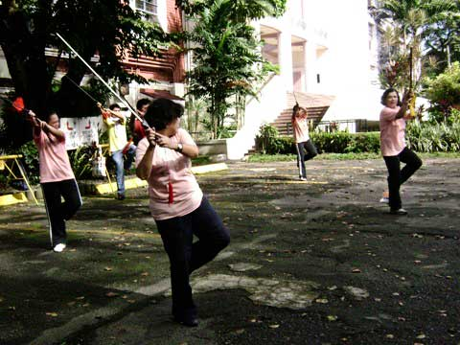
Members practice Tai Chi movements with swords.
It made me realize that even if its movements are like a dance, Tai Chi is not a weak discipline in any way. While the movements are soft and fluid, the principles behind it are firm and strong. If it was used as training for winning wars before, now it is being used as an exercise for maintaining health, experiencing healing and adopting a harmonious way of life.
I also found out that Tai Chi is not just for the elderly. Students in the class were in the age range of 20 - 60 years old; Ton even has a group that teaches younger kids. With its gentle way of teaching and doing, it is no wonder that Tai Chi is chosen by a growing number of people as their exercise of choice. Tai Chi shows the power of transformation, a practice which we can all use to create more positive experiences in our lives. - GMANews.TV
For more information on Tai Chi, as well as schedules and trainings, you can visit the Peace Blossoms website: http://peaceblossoms.weebly.com/index.html.

Source: http://www.gmanews.tv/story/204997/the-gentle-and-strong-way-of-tai-chi

